BIOGRAPHIES OF AUTHORS

Author 1
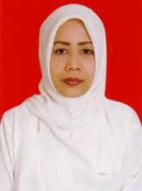 | Khusnul Khotimah (Doctor Management Science) is a Permanent Lecturer at Universitas Yapis Papua (UNIYAP) Jayapura since 2004 until now. Obtained a Doctorate degree with a concentration in Marketing Science in 2016 at UNPAD Bandung Indonesia. The author actively participates in marketing conferences, at national and international levels, domestically and abroad. The author has attended the Post Graduate in Social and Ecological Market Economy Workshop (SEME) in Manado in 2017, in collaboration with Paramadina University Jakarta with Kondrat Adenauer Stiftung Berlin-Germany. And conduct various marketing research, community service as well as keynote speech for various marketing webinar events. Become a reviewer at national and international seminars, as well as a journal reviewer from universities in Indonesia.  She can be contacted at email: khusnul.khotimah1978@gmail.com
Author 2
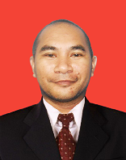 | Imran Syafei M.Nur is a Permanent Lecturer at Universitas Yapis Papua (UNIYAP) Jayapura. He continued his S2 studies in financial management and graduated in 2011 at UNIYAP Jayapura. The author has actively participated in conferences in the field of finance and marketing since he was in college, both at the local and national levels. The author also became a Tutor for two years at the Jayapura Open University in 2020-2021. The author is also listed as an active member of the Indonesian Economic Scholars Association (ISEI) Papua and the Association of Islamic Economists (IAEI) and is active in various organizations. The author also often invited from various parties, agencies, and banks, in providing material in the field of finance and banking marketing. In addition to teaching, the author hones the potential of students in the field of writing in order to grow the spirit of entrepreneurship and grow their reasoning sensitivity. He can be contacted at email:imransyafei27@gmail.com
Author 3
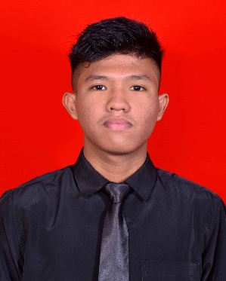 | Dizki Teguh Irfansah is a Fresh Graduate had a number of work experiences in the same field for approximately 1 year. For 1 year working at the company PT. Semuwa Dirgantara as the Human Resource Department, I have a lot of experience in the field of planning and supervision. Coupled with 6 months working at the company PT. Gramedia Asri Media, the customer care/(sales man) division, gave me a lot of experience in handling complaints, I was also given the opportunity to do an internship at PT. Hasjrat Abadi for 3 months with duties and responsibilities as administration and accounting assistant. Proudest achievement during my work is being The Best Selling when working in the salesman at PT. Gramedia Asri Media, also investigated reports related to indications of violations/deviations at PT. Semuwa Dirgantara which is very detrimental materially and immaterially. He can be contacted at email: dizkipangastuti@gmail.com

